SE’nSE call for projects for sustainable start-ups 2021

Seed financing for early stage, sustainable start-ups with positive environmental impact

APPLICATION FORM

This application form and the requested annexes must be completed in English and sent before 03 May 2021, midnight, to sense@fgf.be.

Based on the investor presentation deck, the jury will pre-select 15 projects. These candidates will be invited to fill out a complete application (approx. 12 pages) that will delve deeper in the details. The jury will then invite 8 applicants to pitch their project in front of the jury end of September or beginning of October.

With the support of :

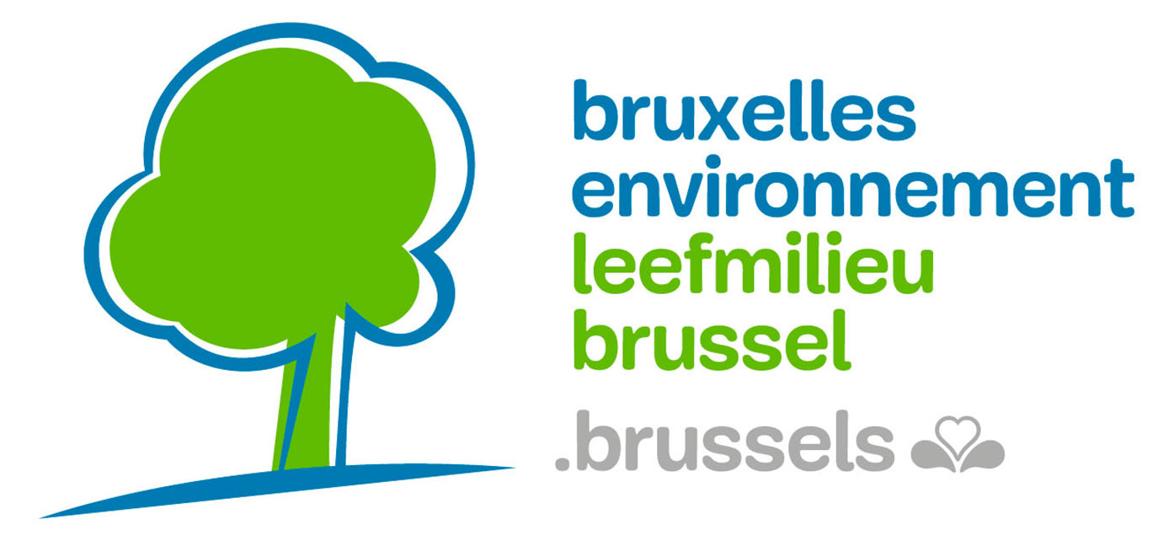
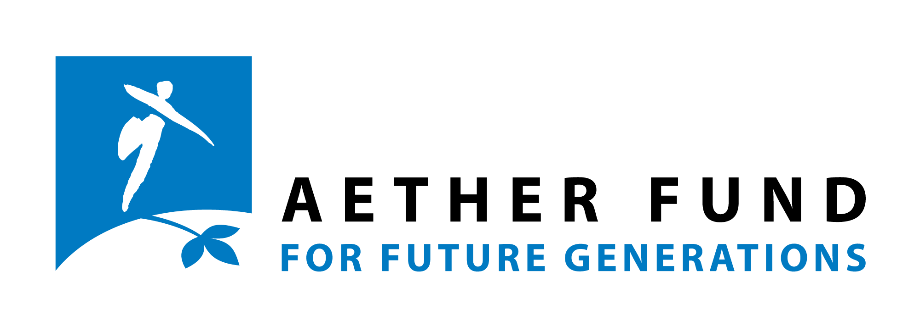
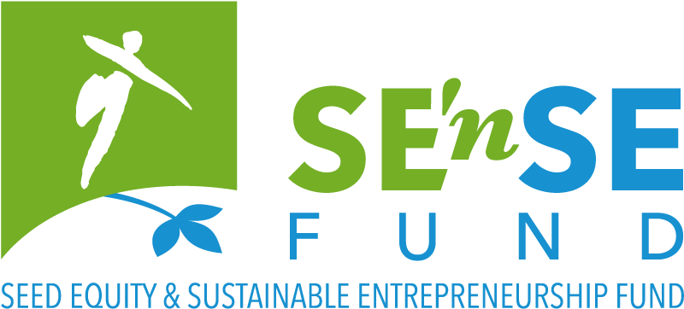
- Investor deck
Please provide us with an investor slide presentation in pdf-format of maximum 20 slides.
These are several items typically included in an investor deck:
- Project Description (name of your company + logo + what you do) *
- The problem
- The solution
- Environmental impacts: indicators, measurement/tracking, competitors*
- Business Model*
- Market Analysis (target market, audience/customers)*
- Competition (how you fit in a competitive landscape, advantages…)
- Marketing Strategy
- Fundraising Strategy
- Milestones (i.e., Operational Gantt-chart, early adopters, already been proven)
- Technical third-party validation
- Awards/Subsidies/Crowdfunding/Partners
- Team and experience (payroll, complementarity…) *
- Support of Incubator/Accelerator/Advisors
- Financials (P&L, cash flow, equity structure) – including how much is requested from SE’nSE*
- The financial difference the SE’nSE funding will make - what exactly would be funded with the requested amount*
- The extra-financial difference the SE’nSE support will make (networking, visibility…) *
- Demo, visuals, prototype,…

The content and lay-out of the slides are of your choice. You may decide not to include all these items, to add others or to regroup some, but the information marked with (*) is compulsory to include in order to be eligible.

- Short description of your project

Please provide a short pitch of your project (max 50 words)

- Contact person

Name

First name

Date of Birth

Nationality

Street and number

Box

Post code and municipality

Country

Phone number

E-mail address

Current working situation
Please tick all the boxes that apply to your situation.

employee
self-employed
additional self-employed activity
retired
student
volunteer
looking for work
other:

- Communication

How did you hear about this call?
From the Foundation for Future Generations:
website
social media
mailing
From another organisation: which one?
Other:

Would you like to receive the newsletter of the Foundation for Future Generations?
Yes please
Newsletter FR
Newsletter NL
No thanks

- Field(s) of activity

In which fields will your project be active?

Agriculture & Rural Affairs
Architecture, Building & Spatial Pl.
Arts, Culture & Entertainment
Design
Fashion
Education & Training
Energy & Climate
Biodiversity
Sustainable Finance
Food Production
Health
Hi-Tech
Industry
International Solidarity
Materials & Waste
Participation & Democracy
Horeca
Transport & Mobility
Water
Social Equality & Diversity
Sustainable behavior & Consumption
Other:

- Privacy

Your personal data will be saved in the database of the Foundation for Future Generations and will only serve to send you the requested the information and/or provide you the requested services. The Foundation will not share this data with third parties. According to the new ‘General Data Protection Regulation’ in force since 25 May 2018, you may at any time ask the Foundation consult, change or delete this data.

All members of the jury will sign a non-disclosure agreement, and the Foundation for Future Generations will ensure that no information in this file is revealed nor transmitted to third parties.

Declaration on honour

Declaration on honour that all eligibility criteria are met.
Required for ALL applications to the SE’nSE funding.
To be completed and signed by the person legally authorised to sign on behalf of the applicant organisation.

My organisation:
☐ has a significant (potential) positive impact on the environment
☐ is an existing early stage start-up business, established no longer than 3 years ago
☐ is located in Belgium
☐ shows potential recurring revenue streams that cover at least its cash needs, including repayment of the loan

☐ has total projected financial needs between 100.000 and 1.000.000€ over the next 2 years

☐ (in case you have already applied in a previous SEnSE call) has brought significant modifications to its project since the last application

As an entrepreneur:
☐ I plan to work full time and I (as a member of the team) am responsible for the daily management of the company

☐ I have never been prosecuted for fraud

I certify that all information contained in this application is correct to the best of my knowledge and that I am aware of the content of the annexes to the application.

By signing this declaration on honour, I accept all the eligibility criteria set out in the Guidelines of the SE’nSE fund related to the call under which I apply.

Done at (city, country): Date (dd/mm/yyyy):

Name (name, position):

(Electronic) Signature:

