SE’nSE call for projects for sustainable start-ups 2020

Seed financing for early stage, sustainable start-ups with positive environmental impact

APPLICATION FORM

This application form and the requested annexes must be completed in English and sent before 26 May 2020, midnight, to sense@fgf.be.

Based on this form and annexes, the jury will pre-select 8 projects. These candidates will be asked to fill out a 2nd form focusing on their environmental impact. They will be invited to pitch their project in front of the jury end of September or beginning of October.

The Foundation for Future Generations, VITO and Econocom are developing are framework to help start-ups and investors prepare and analyse investment dossiers. At this stage we are gathering useful inputs from start-ups. We invite you to fill out the Impact Measurement Survey (this is not compulsory and this will not be taken into account by the jury in the selection process).

Please be as concise as possible. The completed form may not exceed 16 pages (not counting this page and section F).

With the support of :
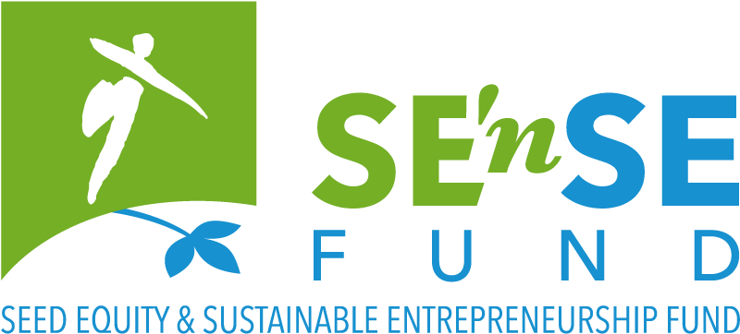
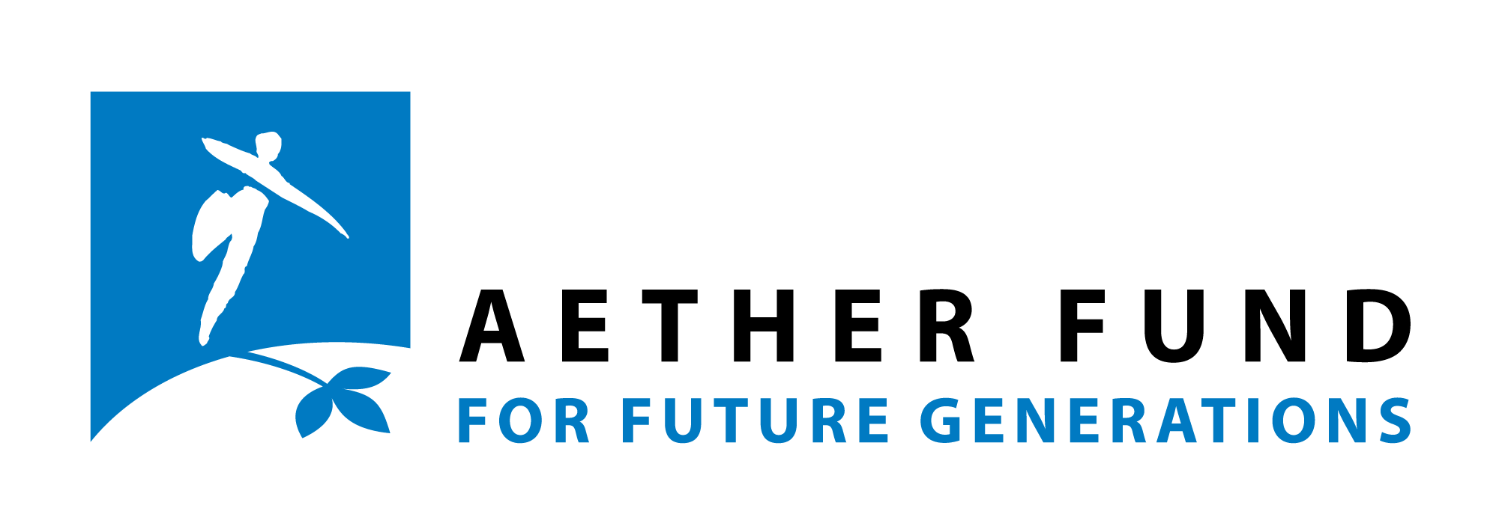
- Summary of the project (name of project/company)

This pitch should include a description of: (i) the product/service you are offering; (ii) its (ideally quantified) environmental impact; (iii) its Unique Selling Proposition; (iv) key financial figures such as sales and bottom line over next years. Make sure you make a compelling case for your project.
You can copy-paste some elements from the next sections to fill this one-page summary.
Max 3500 characters, including spaces.

- Project

Please describe the product or service that you are planning to put on the market, as well as the (environmental, social…) needs/problems you seek to address.
This description might be used in future public communication (newsletter, website, annual report), with your consent, so please be as clear and as concrete as possible (max 1500 characters incl. spaces).

Environmental impact and sustainability

Please briefly describe the key aspects of your project’s positive impact on the environment

This short “environmental impact pitch” might be used in future public communication (max. 500 characters incl. spaces)

Addressing GHG emissions

Have you assessed the order of magnitude of the GHG emissions that will be generated by your project? Have you assessed an order of magnitude of avoided emissions thanks to you project?

Have you identified your project’s major sources of GHG emissions, and of GHG emissions reduction?

How do/will you measure and monitor over time your project’s emissions (which tools, monitoring systems, calculators, …)?

What measures have you considered/taken to reduce your project's GHG emissions and/or maximize the avoided emissions that your project would allow?

Addressing other environmental impacts (water, pollutants, biodiversity, natural resources, …).

How do/will you assess the environmental impact other than CO2 described above?

This includes quantitative and/or qualitative impact measurement of your product/service on a local and a global level (, …). Are you using specific assessment/reporting or certificating system, if any (SROI, RCT, LCA, OVAM ecolizer…)?

Addressing the broader scope of sustainability

How do you (plan to) live the sustainability values, or in other words to integrate the dimensions of sustainable development (People, Planet, Prosperity, Participation) in your mission as well as in your daily activities?

Legal structure

When was/will your company (be) created?

Where is/will your company (be) located? (Full address)

What is/will be the legal form of your company?

Enterprise number (if the company has already been created)

Financial information

What are the total projected financial needs to realise your project?
- in the coming year 2020-2021:
- in the coming five years 2020-2024:

Please explain (summarise) the numbers provided in the P&L spreadsheet (annex).

What will be your personal contribution?

Other contributions in equity?

External financing (banks, subsidies or other)?

What is the amount of financial support that you are applying for from the SE’nSE Fund?
Please enter the amount with no decimal point and no commas, max. 50 000 €.

Why are you applying for the SE’nSE Fund?
Explain briefly what difference the SE’nSE loan would make to your project and for what expenditure it would be used?

Have you received non-financial support from other organisations to set up your project?
(e.g. business coaching, …)

Market and development

Describe the target market. Who will be your clients? Where will your product/service be sold? Who else will benefit from your solution?

Who are your competitors?
Please provide full name and website of all companies/organisations mentioned.

What is your competitive advantage on them? Your unique selling proposition (economically and environmentally)?

How do you plan to attract clients, and how will you keep them? Elaborate briefly on your marketing plan.

How will you price your product/service?

Current achievements: do you already have any evidence confirming the relevance of your problem-solution fit (via interviews, focus groups, benchmarking, …)?

If your project consists in a technical innovation, please mention a person (not involved in the project) who can validate it from a technical point of view.

Please add their contact details.

What are the different phases of development of your company and the timing that you have in mind?

How many jobs do you plan to create in the 5 coming years? Please explain briefly.

What do you see as the main evolutions in your sector in the coming years (regulation wise and market wise)?

In which fields will your project be active?

Agriculture & Rural Affairs
Architecture, Building & Spatial Pl.
Arts, Culture & Entertainment
Design
Fashion
Education & Training
Energy & Climate
Biodiversity
Sustainable Finance
Food Production
Health
Hi-Tech
Industry
International Solidarity
Materials & Waste
Participation & Democracy
Horeca
Transport & Mobility
Water
Social Equality & Diversity
Sustainable behavior & Consumption
Other:

- Team

Who is/will be part of the team? What will be their respective responsibilities within the company Please mention relevant experiences, assets and added values to succeed in this project of each member, and mention whether it is their first activity as entrepreneur (max 4 members).

What motivated you to start this project?

Have you already been prosecuted for fraudulent bankruptcy or been subjected to protest? If so, please explain.

- Contact person

Name

First name

Date of Birth

Nationality

Street and number

Box

Post code and municipality

Country

Phone number

E-mail address

Current working situation
Please tick all the boxes that apply to your situation.

employee
self-employed
additional self-employed activity
retired
student
volunteer
looking for work
other:

- Financial details
Fill in only if the company has already been created

Name of your bank

IBAN/Bank account number

BIC code (SWIFT)

Account holder

- Annexes

Your application is not valid without the following annexes:
- CV (A4 format in PDF, max 2 pages) of relevant team members (max 4 persons)
- SE’nSE Profit & Loss spreadsheet
Feel free to adapt template to your needs, but try to keep it concise.

Not-mandatory annexes (may be added if available):
- The financial plan of your company.
- The financial report(s) of the past year(s)).
- Any relevant diagrams or images explaining how your project works.
- The survey (FR or NL) on impact measurement
Especially for more technical projects.

The completed application form and annexes must be submitted before 26 May 2020, midnight
to sense@fgf.be.

- Communication

How did you hear about this call? *
From the Foundation for Future Generations:
website
social media
mailing
From another organisation: which one?
Other:

Would you like to receive the newsletter of the Foundation for Future Generations? *
Yes please
Newsletter FR
Newsletter NL
No thanks

- Privacy

Your personal data will be saved in the database of the Foundation for Future Generations, and will only serve to send you the requested the information and/or provide you the requested services. The Foundation will not share this data with third parties. According to the new ‘General Data Protection Regulation’ in force since 25 May 2018, you may at any time ask the Foundation consult, change or delete this data.

All members of the jury will sign a non-disclosure agreement, and the Foundation for Future Generations will ensure that no information in this file is revealed nor transmitted to third parties.

