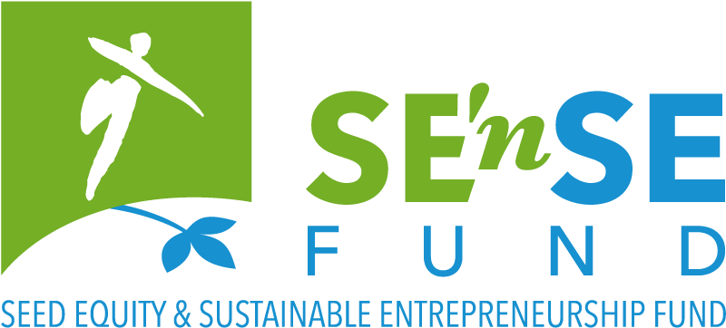

Seed financing for early stage, sustainable projects with significant positive environmental impact

This application form must be completed in English and submitted, together with the requested annexes, before 27 June 2019, 24h00 to sense@fgf.be or sense@stg.be.

Please be as concise as possible. The completed form may not exceed 15 pages.

* = mandatory field

- A few questions about your project

Name of your project and/or company. *
This name will be used in our communication (jury, website, annual report).

Please briefly describe your project (max 700 characters incl. spaces). *
This description will be used in our communication (jury, website, annual report), so please be as clear and as concrete as possible.

Please describe the (environmental, social, …) need/problem your project addresses. *

Please describe the product or service that you are planning to put on the market. How does this address the need/problem described above? *

Please describe your project’s impact on the environment. *

How will you assess the environmental impact described above? *
This may include:
- impact of your products/services/processes
- on a local and a global level
- based on quantified targets and indicators (energy, pollutants, biodiversity, natural resources, …)
- or specific assessment/reporting or certificating system, if any (SROI, RCT, …)?
- Other…

How do you (plan to) live the sustainability values, or in other words to integrate the dimensions of sustainable development (People, Planet, Prosperity, Participation) in your mission as well as in you daily activities? *

The company

When was/will your company (be) created? *

What is/will be the legal form of your company? *

Where is/will your company (be) located? *

Budget/Support

What are the total projected financial needs to realise your project? *
- in the coming year 2019-2020:
- in the coming five years 2019-2023:
Please explain the numbers provided in the P&L spreadsheet (annex). *

What will be your personal contribution? *

Other contributions in equity? *

External financing (banks or other)? *

Subsidies? *

What is the amount of financial support that you are applying for from the SE’nSE Fund? *
Please enter the amount with no decimal point and no commas.

Why are you applying for the SE’nSE Fund? *
Explain briefly what difference the SE’nSE Fund would make to your project and for what expenditure you would use the support?

Have you received non-financial support from other organisations to set up your project? *
(e.g. to build your business model, …)

- Details about your project

Describe the target market. Who will be your clients? Who else will benefit from your solution? *

Who are your competitors? *
Please provide full name and website of all companies/organisations mentioned.

What is your competitive advantage on them? Your unique selling proposition (economically and environmentally)? *

How do you plan to attract clients, and why/how will you keep them? Elaborate briefly on your marketing plan. *

How will you price your product/service? *

Current achievements: have you already any evidence confirming the relevance of your problem-solution fit (via interviews, focus groups, benchmarking, …)? *

If your project consists in a technical innovation, please mention a person (not involved in the project) who can validate it from a technical point of view.

Please add their contact details.

What are the different phases of development of your company and the timing that you have in mind? *

How many jobs do you plan to create in the 5 coming years? Please explain. *

What do you see as the main evolutions in your sector in the coming years (regulation wise and market wise)? *

Where will your project be conducted (regions/countries)? *

In which fields will your project be active? *

Agriculture & Rural Affairs
Architecture, Building & Spatial Pl.
Arts, Culture & Entertainment
Design & fashion
Education & Training
Energy & Climate
Biodiversity
Expertise & Research
Sustainable Finance
Food Production
Health
Hi-Tech
Industry
International Solidarity
Materials & Waste
Participation & Democracy
Horeca
Transport & Mobility
Social Equality & Diversity
Sustainable behavior & Consumption
Other:

- Specific questions about your team

What will be your responsibility within the company? *

Who else will be part of the Executive team? Please briefly explain responsibilities and experience of each member (max 3 additional members) *

What motivated you to start this project? *

Is this your first activity as an entrepreneur? Please explain. *

What are your assets, your added value to succeed with your project? *

Have you already been prosecuted for fraudulent bankruptcy or been subjected to protest? If so, please explain. *

- A few questions about you as a candidate

Practical details

Name *

First name *

Date of Birth *

Place of birth *

Nationality *

Street and number *

Box

Post code and municipality *

Country *

Telephone number
Please write the number in international standard form, e.g. +32 2 511 18 40.

Mobile phone *
Please write the number in international standard form, e.g. +32 2 511 18 40.

E-mail address *

Current working situation *
Please tick all the boxes that apply to your situation.

employee
self-employed
additional self-employed activity
retired
student
volunteer
looking for work
other:

- Financial details of the company
Fill in only if the company has already been created

Name of your bank

IBAN/Bank account number

BIC code (SWIFT)

Account holder

Enterprise number

- Annexes

Your application is not valid without the following annexes:
- CV (A4 format in PDF, max 2 pages) of relevant team members (max 4 persons, max 2 pages each);
- SE’nSE Profit & Loss spreadsheet.
Feel free to adapt template to your needs, but do not exceed 3 pages.

You may join any relevant diagrams or images explaining how your project works.
Especially for more technical projects. Not mandatory. Any additional text will not be taken into consideration.

The completed application form and annexes must be submitted before 27 June 2019, 24h00
to sense@fgf.be or sense@stg.be.

- Miscellaneous

In case you are not selected as a laureate, do you agree to appear on the website (and other communications) of the Foundation for Future Generations? *
Yes
No

How did you hear about this call? *
From the Foundation for Future Generations:
website social media mailing
From another organisation:
which one?
Other:

Would you like to receive the newsletter of the Foundation for Future Generations?
Yes please
Newsletter FR Newsletter NL
No thanks

- Privacy

Your personal data will be saved in the database of the Foundation for Future Generations, and will only serve to send you the requested the information and/or provide you the requested services. The Foundation will not share this data with third parties. According to the new ‘General Data Protection Regulation’ in force since 25 May 2018, you may at any time ask the Foundation consult, change or delete this data.

