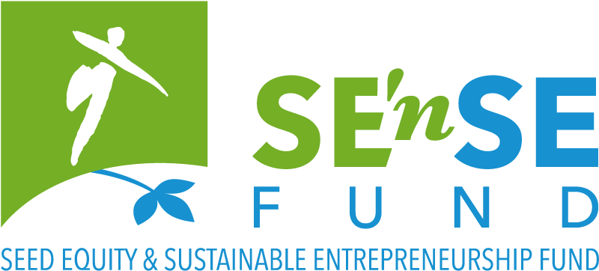

Seed financing for early stage quality environment-driven sustainable projects

This application form must be completed in English and submitted before 3 July 2018, 24:00 to the following address: sense@fgf.be
Please be as concise as possible. The completed form cannot exceed 15 pages.

* = mandatory field

- A few questions about your project

Name of your project/company. *
This name will be used in our communication (jury, website, annual report). So please be as clear and as concrete as possible.

Please briefly describe your project (no more than six sentences). *
This description will be used in our communication (jury, website, annual report). So please be as clear and as concrete as possible.

Please describe the (environmental, social, …) need/problem you are planning to address. *

Please describe the product or service that you are planning to put on the market. How does this addresses the need/problem described above? *

Please describe your project’s impact on the environment. *

How will you assess the environmental impact described above? *
This may include:
- Impact of your products/services and of your processes
- On a local and a global level
- Quantified targets and indicators (energy, pollutants, biodiversity, natural resources, …)
- Specific assessment/reporting or certificating system, if any?
- Other…

How do you plan to live your sustainability values (People, Planet, Prosperity, Participation)? *

The company

When was/will your company (be) created? *

What is/will be the legal form of your company? *

Where is/will your company (be) located? *

Budget/Support

What are the total projected financial needs, in the coming five years, to realize your project? Please explain. *

What will be your personal contribution? *

Other contributions in equity? *

External financing (banks or other)? *

Subsidies? *

What is the amount of financial support that you are applying for from the SE’nSE Fund? *
(Please enter the amount with no decimal point and no commas)

Why are you applying for the SE’nSE Fund? *
Explain briefly what difference the SE’nSE Fund would make to your project and for what expenditure you would use the support?

Have you received non-financial support from other organizations to set up your project? *
(e.g. to build your business model, …)

- Details about your project

Describe the target market. Who will be your clients? Who else will benefit from your solution? *

Who are your competitors? *
Please provide full name and internet site for all companies/organizations mentioned

What is your competitive advantage on them? Your unique selling proposition (economically and environmentally)? *

How do you plan to attract clients, and why/how will you keep them? Elaborate briefly on your marketing plan. *

How will you price your product/service? *

Current achievements: have you already any evidence confirming the relevance of your problem-solution fit (via interviews, focus groups, benchmarking, …)? *

If your project consists in a technical innovation, please mention a person (not involved in the project) who can validate it from a technical point of view.

Please add their contact details

What are the different phases of development of your company and the timing that you have in mind? *

How many jobs do you plan to create in the 5 coming years? Please explain. *

What do you see as the main evolutions in your sector in the coming years (regulation wise and market wise)? *

Where will your project be conducted (regions/countries)? *

In which fields will your project be active? *

Agriculture & Rural Affairs
Architecture, Building & Spatial Pl.
Arts, Culture & Entertainment
Design & fashion
Education & Training
Energy & Climate
Environment
Expertise & Research
Finance

Food
Health
Hi-Tech
Industry
International Solidarity
Materials & Waste
Participation & Democracy
Participation & Democracy
Trade & Horeca
Transport & Mobility
Seniors
Social Equality & Diversity
Sustainable behaviours
Other:

- Specific questions about your team

What will be your responsibility within the company? *

Who else will be part of the Executive team? Please briefly explain responsibilities and experience of each member (max 3 additional members) *

What motivated you to start this project? *

Is this your first activity as an entrepreneur? Please explain. *

What are your assets, your added value to succeed with your project? *

Have you already been prosecuted for fraudulent bankruptcy or been subjected to protest? If so, please explain. *

- A few questions about you as a candidate

Practical details

Salutation *

Surname *

First name *

Date of Birth *

Place of birth *

Nationality *

Street *

Number *

Box

Country *

Post code and municipality *

Telephone number
(Write the number in international standard form, e.g. +32 2 511 18 40)

Mobile phone *
(Write the number in international standard form, e.g. +32 2 511 18 40)

E-mail address *

Current working situation *
(Please tick all the boxes that apply to your situation

retired
student
receiving benefits
volunteer
looking for work
employee
self-employed person
additional self-employed activity
other:

- Financial details of the company
Fill in only if the company has already been created

Name of your bank

IBAN/Bank account number

BIC code (SWIFT)

Account holder

Enterprise number

- Enclosures

Please send your completed enclosures together with your completed application. Your application is not valid without following enclosure(s):

Please add your CV (A4 format in PDF, max 2 pages) as well as the CV of other relevant team members (max 2 additional persons, max 2 pages each).

Please fill in the attached Profit & Loss spreadsheet, feel free to adapt to your needs but do not exceed 3 pages.

Please join any relevant diagrams or images explaining how your project works.
Especially for more technical projects. Not mandatory. Any additional text will not be taken into consideration.

- Miscellaneous

If you are not selected as a laureate, but the jury considers your project relevant enough to communicate on, do you agree to appear on the website of the Foundation and other communication material? *
Yes
No

How did you hear about this call? *
A communication of the Foundation: our website social media mailing
From another organization: which one? …
Other: …

Subscribe to the newsletter of the Foundation for Future Generations:
Newsletter FR
Newsletter NL

